**CHAPTER-1**

**INTRODUCTION** _______________________________________________

**1.1 Introduction**

This project will give us the information about railway reservation. We have tried our best to make the complicated process of Reservation System as simple as possible. The basic functions being performed by our system are reservation and cancellation. This system is basically concerned with the reservation and cancellation of railway tickets to the passengers. To be more specific, our system is limited in such a way that a train starting from a particular source will have a single destination. We have tried to design the Project in such a way that user may not have any difficulty in using this & further expansion is possible without much effort. Customers can find the proper and correct information about the railway and shows that:

* It reserves and cancels seats for the passenger.
* It contains information about the trains.
* It contains information about the Seat Availability.
* Reservation Possibilities.
* Train Ticket booking.

**1.2 Problem Statement**

A software has to be developed for automating the manual railway reservation system. Now days all the new product of intelligence carries out some new flavor of technology. But some are still referring manual procedure to reserve train tickets. Their system is like we have to go to station and reserve ticket then pay on notes.

The system should have distributed functionalities as described below:

**1.Reserve seat:**

A passenger should be able to reserve a seat in the train specified by him if available. For this he has to fill the required information with details about his journey. Admin checks for the availability of the seat in the train and if the seat is available then he makes entries regarding train name, train number, date of journey, start place, destination.

**2.Cancel reservation:**

There may arise a case when the passenger wants to cancel his reservation. For this he has to fill a cancellation form providing all the details about the ticket reserved by him. **3.Update train information & report generation:**

Only the Admin has the right to make changes in train details (add train, delete train, view passengers). The system should also be able to generate report when needed in the form of reservation charts, train schedule charts etc.

**4.Login:**

The users don’t need any password for booking ticket. Only the admin need specified password for access to the admin panel. This provides security from unauthorized access.

**5.View reservation status & train schedule:**

All the users should be able to see the information about the reservation status & train schedule, train name, train number etc.

**1.3 Motivation**

If we think about our countries railway reservation, there are too many lacking and some issues those are should be removed. We had found some procedure to make some solution for those issues. That’s why we were willing to make a system like this. The reasons for what we motivated and started our job for this system are given below.

i)In the manual way of reserving, where we have to go to the station and then reserve our tickets. We feel it’s quite inappropriate in now days. So we felt it should be changed and started to create this project. This project models a portion of the existing online railway reservation system.

ii)It provides a comprehensive set of features to enhance their operational units.

iii)It evaluate their performances in different scenarios.

iv) This project will suggest modifications for greater efficiency. There are a lot of scope to modify this project for betterment.

v) We have seen there are too many recourses are available to make a dynamic process like this. We had tried to establish a well-organized project like this. We have survey too many research papers and review many top ranking railway reservation websites. Finally, we have decided to work with this project that we can do with best of our knowledge.

**1.4 Objectives**

During the past personnel function has been transformed from a relatively obscure record keeping staff to central and top level reserving function. There are many factors that have influenced this transformation like technological advances, professionalism. A reservation system is designed to handle all the primary information of railway those are required to reserving tickets. Separate files are maintained to handle all the details required for the correct statement calculation of the whole system.

This project intends to introduce more user friendliness in the various activities such as record update of reservation, book ticket, cancel ticket, search for particular ticket. The searching of record has been made quite simple as all the details of the passenger can be obtained by simply keying in the identification of that passenger. The entire information has maintained in files and whoever wants to retrieve can’t retrieve, only admin can retrieve the necessary information which can be easily be accessible from the file. And these processes are mostly necessary for any reservation system.

The activities of our System are going to be like:

1. View information
2. Book ticket
3. Cancel ticket
4. Admin
5. View passengers
6. Add train
7. Delete train
8. Back
9. Search for particular ticket
10. Exit

**1.5 Contributions**

A group teamwork is all about contribution and sacrifice. It is not different for us. We three have tried our best to give all the effort that we can in our project. The contributions are described below.

**i) Ticket reserving**

In this system same ticket cannot be purchased by multiple user. So there will be no corruption. It is the most important thing of this project.

**ii)** **Confirmation massage**

The user will get a confirmation massage. When any user book ticket then he will get massage instantly.

**iii) Cancellation Procedure**

The passenger can cancel his reservation if he thinks the reserved tickets are not appropriate for his or any other issues.

**iv) Search for particular ticket**

A user can search particular ticket. After he inputs a train number he can see if the ticket is booked or not.

**v) View information**

A user can view information about SI, Train number, Train name, Start place, Destination place Price, Seat, Time of the train.

**vi) Eye-catchy design**

A good design can attract the users. So we have decorated our project so that the users can get it more organized and attractive than others. But for providing the best of our knowledge we have tried a lot. The amount of time we have given for group discussion and teamwork is huge. Basically we have categorized our works into several types and also made a schedule for each little works. We executed our all the works within the given time as well we communicate with each other in scheduled time. We have to face many problems in our project to make the layout of our frontend.

**1.6 Organization of Project Report**

We have tried to decorate this contain as we put our all the topic and their abbreviation.

So, first come chapter one. Here all the works we do are introducing our project. The existing system that is presently using in manual procedure. Then the problems those are noticed by the users from existing system.

It is all about how we monitored our works and contribution to execute our goal. The works and which works we have tried to implement. These are all from chapter one.

In chapter two we described the existing system and their supporting literature. Some diagram has been introduced. Some facilities and technology those are used in this project have been explained. Also the overall concept about the restrictions of existing system introduced in this section.

In chapter three we have discussed about our proposed model. How to and what to include in our project are well discussed on that chapter. The feasibility studies are included on that chapter. Also there are many purpose model and goal statement are written. Different types of diagram provided also.

In chapter four the implementation parts are given sequentially. The others testing result are included in this chapter.

Chapter five is all about result analysis. The screenshots and analytical results are shown in this chapter. We also provided the main elementary parts for the best output to make clear concept about this project.

Conclusion and future possibility of working with this project are discussed in chapter six. The overall working experiences and future enhancements are shown here.

**1.7 Conclusions**

As a fresher it was difficult to establish a dynamic project like this. Railway reservation system Project is not about just reserving tickets. The others facilities of this project was more than a reserving ticket. The facilities we have provided in this project was just fabulous to see. It was not an easy task for us. As inexperienced programmers, to create dynamic project like this was too tough. We have tried all the basic knowledge what we know. We have produced our previous two semesters experience on it. The basic knowledge on Structured programming language (C) was our main target to build up this project. Everything was not always gone at our side. We had to face some critical problems. Thanks to almighty, we were able to recover that situations. We three were really well connected every single time to give our hundred percent on it. Hopefully this will be able to ensure that all the requirements are available as a dynamic Railway reservation system.

**CHAPTER-2**

**EXISTING SYSTEM**

**________________________________________________**

**2.1 Introduction**

Our Railway reservation system is producing some specific feature. If we look at the present curriculum of our existing system, then we see that almost all the Railway reservation system following the traditional booking. In this project we use Structured programming language(C).

It is a very simple project so the user can easily flexible with it. It produces an easier and flexible way of booking. We have tried our best to make the complicated process of Railway Reservation System as simple as possible. We have tried to design the Project in such a way that user may not have any difficulty in using this package & further expansion is possible without much effort. Even though we cannot claim that this work to be entirely exhaustive, the main purpose of our exercise is reserving tickets. We are confident that this package can be used more nicely and accurately.

**2.2 Existing System**

The Railway Reservation Systems currently runs a manual reserving system and therefore requires passengers to only book for tickets or any other. A lots of restrictions are founded in existing system. Those are discussed below.

**i) Payments**

As it is a simple project so we did not include any option to give the payment of tickets.

**ii) False Report**

Sometimes management is given false reports concerning the work flow of the railway service and employees also give falsified pricing information to passengers from time to time.

**iii) Useless Record**

From an employee’s account, details of passengers are hardly used in the workflow and that also, records are not properly kept; books used to keep records are disposed of when they get filled up.

**2.3 Used Diagrams**

When we are going to implement a project on basis on its all the requirements and objectives we need some extra activities those are essential to execute that system more easily and more systematically. Diagrams are those elements which are responsible to help us to make our job more comfortable. Here we have discussed about some diagrams. Those are given bellow-

**2.3.1 Use Case Diagrams**

A use case diagram can summarize the details of your system's users and their interactions with the system. To build one, we'll use a set of specialized symbols and connectors [11]. An effective use case diagram can help our team discuss and represents:

1. Scenarios in which our system or application interacts with people, organizations, or external systems
2. Goals that our system or application helps those entities (known as actors) achieve
3. The scope of our system.

A use case diagram doesn't go into a lot of details. For example, we don't expect it to model the order in which steps are performed. Instead, a proper use case diagram depicts a high-level overview of the relationship between use cases, actors, and systems. An example of a use case diagram has been shown in Figure 2.1. The experts recommend that use case diagrams be used to supplement a more descriptive textual use case.

UML is the modeling toolkit that we can use to build our diagrams. Use cases are represented with a labeled oval shapes. Stick figure represents actors in the process, and the actor's participation in the system is modeled with a line between the actor and use case. To depict the system boundary, drawing a box around the use case itself.

Example:

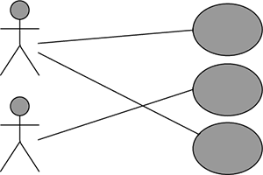

**Figure 2.1: Use Case Diagram**

Use Case diagrams are ideal for:

1. Representing the goals of our system-user interactions.
2. To define and organize functional requirements in a system.
3. To specify the context and requirements of a system.
4. Modeling the basics flow of events in a use case [11].

**2.3.2 Data Flow Diagram**

**i) 0- level DFD:**

Cancelation ticket

Passengers info

Reserve/cancel info

up/down train info

Admin

Ticket info

Reservation ticket

Passenger

**Figure 2.2: Zero level DFD diagram**

**ii)1-level DFD:**

Reservation Storage file

Passengers

Up storage

Down storage

**Figure 2.3: One level DFD diagram**

**iii)2- level DFD:**

Manage Customer details

Admin

Manage reserving details

Manage ticket details

Manage Customer details

**Figure 2.4: Two level DFD diagram**

**2.4 Technology Used**

**2.4.1 Code Blocks:**

Code Blocks is a free, open source cross-platform IDE (integrated development environment) that supports multiple compilers. Currently, Code Blocks is oriented towards C, C++, and Fortran. Code Blocks is being developed for Windows and Linux. Version 17.12 is the latest stable release. (release date: December 30, 2017).

Features of Code Blocks:

* Compilers
* Code editor
* Debugger
* GUI designer
* User migration
* Project files and build system

**2.5 Conclusions**

The new era of technology has changed our life by providing more and more facilities. Not different for the railway reservation. It has tried to change the manual process of booking. Railway reservation project is not about just reserving tickets. The others facilities of this project was more than reserving tickets. We have tried to make our system as we want and the user want. Only a user friendly system can be successful otherwise it will go to vain. We have tried to make our system more user friendly. It was not an easy task for us. As inexperienced programmers, to create dynamic project like this was too tough. We have tried all the basic knowledge what we know. We have produced our university life experienced on it. The basic knowledge on Structured Programming Language(C) was our main target to build up this project. Everything was not always gone at our side. We had to face some critical problems. Thanks to almighty, we were able to recover that situations. We three were really well connected every single time to give our hundred percent on it.

**CHAPTER-3**

**PROPOSED MODEL**

**________________________________________________**

**3.1 Introduction**

Our proposed model stands for adding new facilities that is not present existing system. Some developed countries are providing all the requirements as the users expect. But the country like Bangladesh here we can see that most of the Reservation system are following their traditional system and procedure. We have put all the procedure schedule and technique so that anybody can understand how the project established. We have tried to design the Project in such a way that user may not have any difficulty in using this package & further expansion is possible without much effort. Even though we cannot claim that this work to be entirely exhaustive, the main purpose of our exercise is booking tickets. The diagrams and the flow chart have been introduced. And also shown for our Railway Reservation System.

**3.2 Feasibility Study**

Feasibility study for our Railway Reservation System evaluated our project’s potential for success; therefore, perceived objectivity is an important factor in the credibility of the study for potential investors and lending institutions. The operational, technical and economical statements are introduced for our system. We also need feasibility study. Because a dynamic project like Railway Reservation System here we had to thought about all the environment for this system. If we think about operational and technical feasibility, these two are mostly high rated topic. And everybody who wants to build a project read all the module of these study and make decisions of planning. Because only providing a project is not acceptable if we not think about our whole environment. So, if we think about our now a day’s system then it is most important.

Feasibility Studies were important for our Railway Reservation System. Because-

The information we gather and present in our feasibility study helped us are:

i) Identifying all the things we need to make for the railway reservation work.

ii) Pinpointing logistical and other management-related problems and solutions.

iii) Serving as a solid foundation for developing our system plan.

We are introduced with different types of feasibility study. Their explanations are given right below.

**3.2.1 Technical Feasibility**

Technical Feasibility for our Railway Reservation System is we focused on the technical resources available to the organization. It will help organizations determine whether the technical resources meet capacity and whether the technical team is capable of converting the ideas into working systems. Technical feasibility also involves evaluation of the hardware, software, and other technology requirements of the proposed system. As an exaggerated example.

A technical feasibility study might show that you should go forward with a project but at a specific time. Conducting a feasibility study helps you determine our likelihood of success and can indicate how and when to do a project.

**3.2.2 Operational Feasibility**

This kind of feasibility assessment involves undertaking a study to analyze and determine whether and how well our organization’s needs can be met by completing the project. For our Railway Reservation System operational feasibility studies also analyze how we planned for our project satisfies the requirements identified in the requirements analysis phase of whole project.

Operational feasibility for our project studies are generally utilized to answer the following questions:

**i) Process**

How we decorated our project for the users as they want to use.

**ii) Evaluation**

Evaluating the whole program for all the contents.

**iii) Implementation**

Stakeholder of Railway Management, admin, and end-user tasks [16].

**iv) Resistance**

Railway Reservation Team, and individual resistance and how that [resistance will be handled](https://www.brighthubpm.com/change-management/34940-overcoming-resistance-ignorance-and-denial-in-change-management/)[16].

**3.2.3 Economical Feasibility**

For the dynamic project like Railway Reservation System, Economic Feasibility typically involves a cost or benefits analysis of the project, helping organizations determine the viability, cost, and benefits associated with a project before financial resources are allocated. It also serves as an independent project assessment and enhances project credibility—helping us to determine the positive economic benefits to the organization that the proposed project will provide.

Also virtual services are an ideal destination for an organization, need to do an economic feasibility for a project. And when it comes Railway Reservation System then the highly qualified and experienced professionals from the relative field perform the research with excellent proficiency. While we have done the study we always take care of the essential factors needed to carry out a successful project like this [16].

Our study was based on cost and time. Under the cost based study, we have evaluated the development cost and the operating cost. We also calculated an approximate time frame to receive returns against investment keeping in mind the future value of the project. During the process of economic feasibility study we followed certain best practices to get the desired result. We do certain assumptions on the basis of which we give you solid plan of investment.

**3.3 Non-Functional Requirement**

For our Railway Reservation System, a non-functional requirement are some requirements those specified the criteria’s that can be used to judge the operation of a system, rather than specific behaviors. They are contrasted with functional requirements that define specific behavior or functions of our project.

**3.3.1** **Performance Requirement**

Performance requirements define acceptable response times for system functionality.

1. The load time for user interface screens shall take no longer than two seconds.
2. ii) The login information shall be verified within five seconds.

**3.3.2** **Logical Requirements**

The logical database requirements include the retention of the following data elements.

This list is not a complete list and is designed as a starting point for development.

**1.User-Friendly Interface**

A ticket booking process with a good user-friendly interface will allow customers to easily go through this system. Thus, increasing the chances for booking as customers prefer to stay longer on this system.

**2. Easy Booking Process**

The booking process should include minimal steps. In this project we make the booking process very easy so that it can be used by any person.

**3. Offline working**

This project totally works on offline. So, it becomes very easy to use for the users.

**5. Easy Reservation Management**

Adding the details, we made it easier for the users. So, user can easily book ticket and user can cancel ticket from this system.

**7. Easy Search Option**

Customers must able search for tickets in a particular location and view the availability of tickets.

**3.3.3 Design Constraints**

The Railway Reservation System stand-alone system running in a Windows environment. The system has been developed using Structured Programming Language(C). We have tried all the basic knowledge what we know. We have produced our previous two semesters experience on it. The basic knowledge on Structured Programming Language(C) was our main target to build up this project. Everything was not always gone at our side. We had to face some critical problems. Thanks to almighty, we were able to recover that situations. We three were really well connected every single time to give our hundred percent on it.

**3.3.4** **Security**

Admin and user will have access into the Railway Reservation System. Admin will have to be able to log into the admin panel. Only admin can add train as well as delete train and can view passenger’s information. Access to the various subsystems will be protected by admin log-in screen that requires a password.

**3.3.5** **Maintainability**

The Railway Reservation System is being developed in C. C is structured programming language. Maintenance Engineering is the discipline and profession of applying [engineering](https://en.wikipedia.org/wiki/Engineering) concepts for the optimization of equipment, procedures, and departmental budgets to achieve better [maintainability](https://en.wikipedia.org/wiki/Maintainability), [reliability](https://en.wikipedia.org/wiki/Reliability_engineering), and availability of equipment.

Maintenance, and hence maintenance engineering, is increasing in importance due to rising amounts of equipment, systems, machineries and infrastructure. Since the [Industrial Revolution](https://en.wikipedia.org/wiki/Industrial_Revolution), devices, equipment, machinery and structures have grown increasingly complex, requiring a host of personnel, vocations and related systems needed to maintain them. Maintenance is to ensure a unit is fit for purpose, with maximum availability at minimum costs. Our Railway reservation system is providing all these maintenances through customer’s demand.

**3.4 Functional Requirement**

In Software engineering and systems engineering, a functional requirement defines a function of a system or its component. Functional requirements may be calculations, technical details, data manipulation and processing and other specific functionality that define what a system is supposed to accomplish. Here the functions are described as a set of inputs, the behavior, and outputs.

Functional Requirements for our system are-

**i) Admin’s Login**

For Admin’s login we have require password which is very important for any types of login system.

**ii) Searching for particular ticket**

For Search option the users will get the eligibility to search for particular tickets.

**iii) Booking tickets**

Booking procedure is one of the most important procedure in our system. For booking tickets users will find the facilities of-

1. Can select journey date
2. Can input the amount of ticket he wants to buy.

**iv) For Admin**

Admin can excess different tasks on this system. The admins work included basically-

a) view passenger’s information

b) Add trains

c) Delete trains

**3.5 System Design**

Systems design is the process of defining the architecture, components, modules, interfaces, and data for a system to satisfy specified requirements. System designing in terms of software engineering has its own value and importance in the system development process as a whole. For our Railway Reservation System, we have described all these step by step [20].

**3.5.1 Using of Waterfall Model**

The waterfall model is a project management methodology based on a sequential design process that is shown in Figure 3.1. Much like a waterfall filling lower level pools, phases in the waterfall model flow from one to another [21]. A simple waterfall model has 6 phases:

i) Requirements,

ii) Design,

iii) Implementation,

iv) Verification,

v) Deployment and

vi) Maintenance.

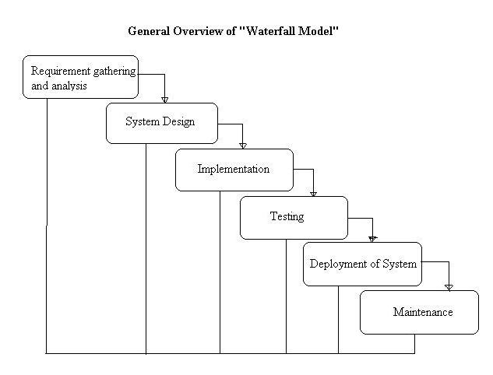

**Figure 3.1: Waterfall Model**

There are some advantages of waterfall model. That’s why we have chosen it. Those advantages are-

i) This model is simple and easy to understand and use.

ii) It is easy to manage due to the rigidity of the model – each phase has specific deliverables and a review process.

ii) In this model phases are processed and completed one at a time. Phases do not overlap.

ii) Waterfall model works well for smaller projects where requirements are very well understood [21].

**3.5.2 Flow Chart**

A flowchart is a diagram that depicts a process, system or computer algorithm. They are widely used in multiple fields to document, study, plan, improve and communicate often complex processes in clear, easy-to-understand diagrams. Flowcharts, sometimes spelled as flow charts, use rectangles, ovals, diamonds and potentially numerous other shapes to define the type of step, along with connecting arrows to define flow and sequence. They can range from simple, hand-drawn charts to comprehensive computer-drawn diagrams depicting multiple steps and routes. If we consider all the various forms of flowcharts, they are one of the most common diagrams on the planet, used by both technical and non-technical people innumerous fields. The flow chart for our hotel management system is given below.

The flow chart for our Railway Reservation System is shown below in figure 3.2 and 3.3 in the next page.

Visitor

View menu

Yes

Login

Yes

Valid password

Yes

Is Admin

No

Admin

Yes

A

B

**Figure 3.2: Flow Chart-1**

B

A

Exit

Stop

Booking the ticket

View information

View passenger’s information

Add trains

Delete trains

Cancel the

Booking ticket

Search for particular ticket

**Figure 3.3: Flow Chart-2**

**3.5.3 Use Case Diagram**

In software and systems engineering, a use case is a list of actions or event steps typically defining the interactions between a role known in the Unified Modeling Language as an actor and a system to achieve a goal. The actor can be a human or other external system. In this section we will discuss about Use Case Diagram on basis of our Railway Reservation system.

**3.5.3.1 Use Case Diagram for Admin**

Admin is one of the major part of our system. Admin has a huge impact on our system. The Use case formalities for admin panel are login, view passengers, add train, delete train, back services-

**i) Login**

For admin there is a password to login.

**ii) View passengers**

Admin can see the number of passengers as well as their name, train number, phone number, seat number and date.

**iii) Add train**

Admin can add train.

**iv) Delete train**

Admin can delete train.

**v) Back**

Admin can back to the menu.

A use case diagram for Admin is drawn below in figure 3.4. Here we can see the admins activity relationships.

Login

Admin

View Passengers room

Add Train

Delete Train

Back

**Figure 3.4: Use Case Diagram for Admin**

**3.5.3.2 Use Case Diagram for User**

These following describes all the tasks of users who wants to book tickets in our system. Their tasks are view information, book ticket, cancel ticket, search for particular ticket [23].

**1) View Information**

User can view train details from our system and they also can view the available ticket rates.

**2) Book Ticket**

The users can very easily book ticket with a very little amount of information.

**3) Cancel Ticket**

Users can easily cancel tickets if they want.

**4) Search for Particular Ticket**

They can search for particular ticket.

**5) Exit**

They can exit from the system very easily.

A use case diagram for user is drawn below in figure 3.5. Here we can see the user’s activity relationships.

View Information

User

Book ticket

Cancel ticket

Search for Particular ticket

**Figure 3.5: Use Case Diagram for User**

**3.6 Flow Chart for Admin**

This following activities defines the Admins activities. The figure 3.11 is drawn to describe how the Admin implementations happens. Actually the database tables are shown in this figure.

Admin implementation:

Admin

Admin Panel

Admin can show passengers information

Manu

Owner reports admin portion of websites

Add train

Admin can add trains

Delete train

Admin can easily delete train

View information

Admin can view the number of tickets passenger book

**Figure 3.6: Admin implementation**

**3.7 User Modules**

This following activities defines user’s modules. In this section we have discussed about several modules those are used in our system.

**i. Menu**

The main page of the Railway reservation system is the entry point for all other options contained in the system. The passengers will be able to begin booked ticket.

**ii. Details**

The main menu is developed in C. This menu will contain links to the other options.

**iii. Other Options**

The menu will not be linked other options rather than the main menu options.

**iv. Error Handling**

This system can easily handle errors and give us a massage.

**3.8 Admin panel**

In this section we described the admins panel. Here all the activities are followed with details Those are-

**3.8.1 Main options**

The main options of the railway reservation system are in the entry of the system. The main page is same as like user menu.

**i. Details**

The main options for admin is developed in C. The page will contain links to the other pages/module. The layout of the page is based on page frames. Each frame will contain a link to a module.

**3.9 Conclusions**

A good project depends on good design and good implementation according to the design. This chapter is actually about the design analysis which contains mainly used method to draw up the system procedure through diagrams, flowcharts and user modules. That means how the system we have designed and implemented. We have tried to make our system as we want and the user want. Only a user friendly system can be successful otherwise it will go to vain. We have tried to make our system more user friendly. We have shown different table and figure in this chapter those are very necessary to implement. Figures are drawn so that to clarify how our project works gone through and how we implemented our project. Some topics are allowed to described in this chapter to explain their works and procedural method. The necessity of this chapter is all about practical implementation of our works strategy. Several types of diagrams are shown in this chapter. Diagrams on basis of our railway reservation system allowed to add in this system so that anybody can find our system procedure. Because diagram is more effective than theoretical elements to understand system procedure and task categories.

**CHAPTER- 4**

**EXPERIMENTAL RESULT**

**________________________________________________**

**4.1 Introduction**

In this chapter, we are going to describe all the experimental and outcomes of our developing project Railway Reservation System. We have put all the procedure schedule and technique so that anybody can understand how the project established. We have tried to design the Project in such a way that user may not have any difficulty in using this package & further expansion is possible without much effort. Even though we cannot claim that this work to be entirely exhaustive, the main purpose of our exercise is reserving tickets in online process instead manually. The diagrams and the flow chart have been introduced. And also shown for our Railway Reservation System.

**4.2 Testing of Various Function**

Testing of various functions are discussed below.

**i) Blank Submission**

Without password any user can look their information and all the feature we have added into our railway reservation except the admin panel. View information, book ticket, cancel ticket and search for particular ticket are decorated as a user want.

**ii) Invalid Password**

If admin put a wrong password, then it shows the massage that there is an error.

**iii) Offline Access**

Offline accessible procedure is available in our Railway Reservation System.

**iv) Confirmation**

A confirmation message will be shown after implementing all the procedure.

**4.3 Result Analysis**

After implementation we have find out our expected result. Every implementation we have carried out different result. This section shows all the various test result just to insure that the system is working.

**4.3.1 Unit Test Cases**

Unit testing is a software development process in which the smallest testable parts of an application, called units, are individually and independently scrutinized for proper operation. Unit testing can be done manually but is often automated [26].

The testing elements are-

**i) Input Values**

The values of empty field should be filled to go to the next procedure.

**ii) Expected Functionalities**

All the functionalities are tested to ensure that they are available to implant their procedural works.

**iii) Output Values**

For the correct input our project will be ok to give perfect reply.

**iv) Path Coverage**

Cover aging the path where all the functionalities are processed also tested and they are absolutely fine.

**v) Abnormal Terminations**

The abnormal terminators those can be very effective are removed so they can’t be able to damage our system.

**vi) Error Message**

For incorrect inputs the system will show the error message.

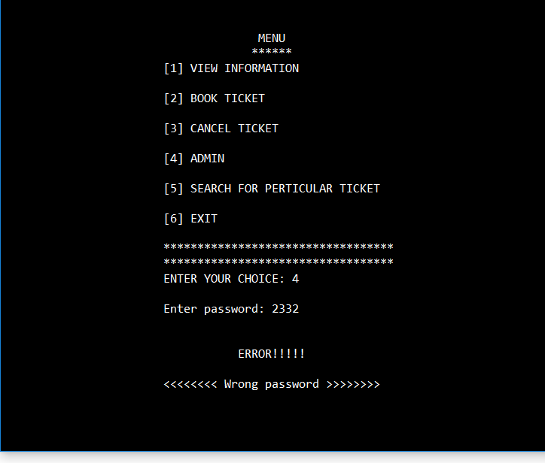

**Figure: 4.1 Showing Error Message**

**vii) Screen Layout:**

Had a good look on screen layout and its fine to proceed.

**4.3.2 Test Scenario**

A test case scenario is any scenario that can be tested. It is also called Test Condition or test possibility. The following table showed some possible test scenario.

|  |  |  |
| --- | --- | --- |
| **Serial No.** | **Test Scenario ID** | **Test Scenario Description** |
| 1 | Test Scenario 1 | Password Match |
| 2 | Test Scenario 2 | Invalid Password |
| 3 | Test Scenario 3 | Password Blanked |

**Table 4.1 Test Scenario**

**4.4 Test Cases**

In the simplest form, a [test case](https://blog.testlodge.com/test-cases/) is a set of conditions or variables under which a tester determines whether the software satisfies requirements and functions properly. A test case is a single executable test which a tester carries out. It guides them through the steps of the test. You can think of a test case as a set of step-by-step instructions to verify something behaves as it is required to behave.

**4.4.1 Test Case 1–Ticket Booking**

**Test Scenario for booking ticket**

**i) View tickets**

User can view if tickets are available and can view other information.

**ii) View Ticket Rates**

User can look at ticket rates.

**iii) Search Ticket**

Searching ticketare available.

**iv) Book Ticket**

Providing valid information user can book ticket.

|  |  |  |
| --- | --- | --- |
| **Serial No.** | **Test** | **Result** |
| Test 1 | View Available Ticket | Result Shown |
| Test 2 | View Rates | Ticket Rates are Shown |
| Test 3 | Search Ticket | Ticket are Shown |
| Test 4 | Book Ticket | Ticket Selected for Reserve |

**Table 4.2 Test Case of Ticket Booking**

**4.5 Application Outcome**

Our project has been developed for several uses in different applications and organizations. The main applications for our system are given below-

**i) Hotel Reservation System**

For any kind of hotel reservation system our system is reliable to use.

**ii) Bus Reservation**

Bus reservation can be considering as an application for our system. Because this reservation is containing the reservation and the cancellation. Also providing the well-organized admin panel facilities.

**iii) Hostel Reservation**

Hostel reservation is quite similar to Railway reservation system. So it can be considered as our systems application outcome.

**iv) Airline Reservation**

Airline reservation needs cancellation and reservation modules. Our system has those facilities. So airline reservation is our another application for use.

Also for any kind of reservation system our system can be used.

**4.6 Conclusions**

The system is built in such a way that it will be useful and user friendly to general user. Result analysis has given a brief that how we execute our overall system through testing, observing and analyzing. This was the proper way to know whether the system is working properly or not. It also means the system provides mainly what kind of facilities and if it’s better and reliable option for people to get train ticket reservation services through our system. Actually different reservation has different knowledge to implement their system procedure. We have tried to make our system as we want and the user want. Only a user friendly system can be successful otherwise it will go to vain. We have tried to make our system more eye catchy and more user friendly. We have shown different table and figure in this chapter those are very necessary to implement. Figures are drawn so that to clarify how our project works gone through and how we implemented our project. Some topics are allowed to described in this chapter to explain their works and procedural method. The necessity of this chapter is all about practical implementation of our works strategy. It has been a great task for us to make it possible. This application of system also belongs in this part that clear we have created our expected Railway Reservation System to support people with saving their time and energy.

**CHAPTER-5**

**USER MANUAL**

**________________________________________________**

**5.1 Introduction**

This chapter contains all the hardware and software requirements for using the system and also user manual for both admin and user. User manual is directional system of a project. It provides the direction to the users who don’t know how to use the software. It denotes which page will come after which one. It also denotes which task we have to do after which one, how to reserve tickets etc.

**5.2 System Requirements**

Our project is an offline based system. User and admin can access the software without any difficulty. Both user and admin don’t need any special requirement. But sometimes for a reason, for smooth performance user or admin need at least a computer those have some qualities.

**5.2.1 Hardware Requirements**

To be used efficiently, all computer software needs certain hardware components or other software resources to be present on a computer. Most software defines two sets of system requirements: minimum and recommended. Minimum requirements mean we should have minimum range of hardware that can supports our whole system. And recommended requirements means our system is going to require a set of hardware’s that must be need to work with our system. Our project named Railway Reservation System is requiring some of the hardware’s that should be provided by the Railway authority. Those all are computer components. Computer hardware is the collection of physical parts of a computer system. This includes the computer case, monitor, keyboard, and mouse. It also includes all the parts inside the computer case, such as the hard disk drive, motherboard and many others. Computer hardware is what we can physically touch [28].

**5.2.2 For Client Sides**

**i) Computer**

The System needs

1) Pentium IV 1GHz

2) Minimum of 512 MB RAM (Recommended)

3) Minimum 30 GB Hard disk for storage

**ii) Server**

This project can open in offline.

**5.2.3 Software Requirements**

To be used efficiently, all [computer software](https://en.wikipedia.org/wiki/Computer_software) needs certain [hardware](https://en.wikipedia.org/wiki/Computer_hardware) components or other software resources to be present on a [computer](https://en.wikipedia.org/wiki/Computer).  These prerequisites are known as software requirements and are often used as a guideline as opposed to an absolute rule. System requirements tend to increase over time. reservation analysts like Railway Reservation system suggest that this trend plays a bigger part in driving upgrades to existing computer systems than technological advancements. A second meaning of the term of System requirements, is a generalization of this first definition, giving the requirements to be met in the design of a system or sub-system.

**5.2.4 For User Sites**

**i) Operating System**

Operating system has to be Windows XP onwards.

**iv) Developing Tool**

VB (Front end).

**5.2.5 User Interface**

User Interface (UI) defines the way humans interact with the information systems. In Layman’s term, User Interface (UI) is a series of pages, screens, buttons, forms and other visual elements that are used to interact with the device.

**5.3 Admin Site**

This part will introduce how will be the admins plan to this system. How will be his contribution in this system. He will be able to see all the data from anywhere of the system. The dashboard will help him make effort able decision for the Railway reservation system. If we look at the admins User Interface, then we will see some procedure that is ready for the admin.

**1) Admin’s Login Page**

This is the what that admin can see after login. The admins login page and the user’s homepage are almost same. The main difference between admins page and the users page is admin have to be provided his password but users don’t need to provide password. Here it is shown in figure 5.1.

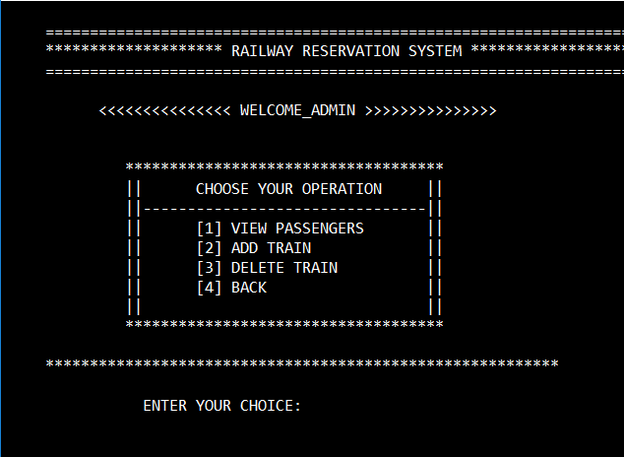

**Figure 5.1: Admin Login Page**

**2) Add Train:**

Admin can add trains in this system.

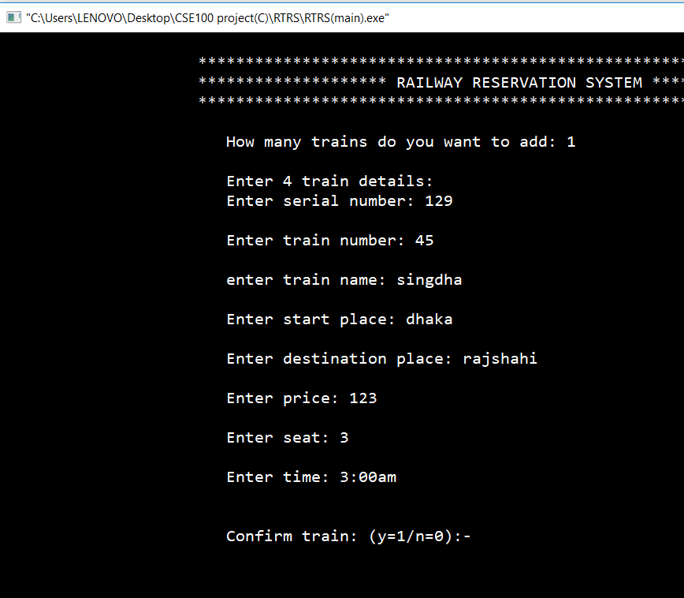

**Figure 5.2: Add Train**

**3) Cancel Ticket**

Canceling ticket will help to the admin to check how many tickets are canceled after booking. User can cancel their booked ticket if they input phone number that they gave at the time of booking ticket. If they can’t provide valid phone number they won’t be able to cancel their booked ticket. It is shown in figure 5.3.

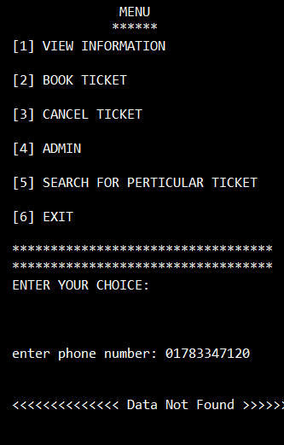

**Figure 5.3: Canceling Ticket**

**4)All passengers list**

This page will show the admin the all the passengers of Railway Reservation System. It is shown in figure 5.4.

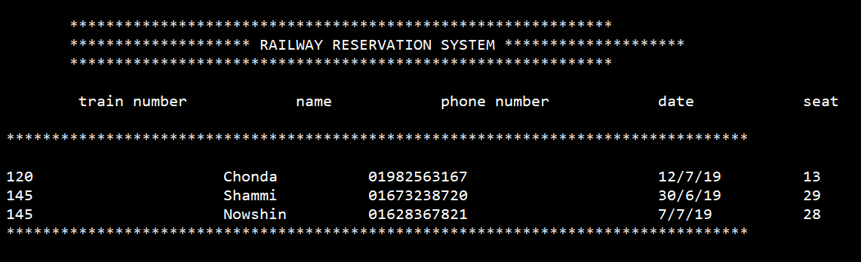

**Figure 5.4: All Passengers List**

**5.4 User Side**

This side will help the general user how to operate the system. How a guest user can see the system. This part will show to the users the different accessibility from the admin panel. This part will help the user to book ticket.

**1) User Menu**

This is how our system Railway Reservation System’s welcome page looks like. A user friendly login can be effective to attract user’s choice. Here we have given importance more. If we see several types of branded railway reservation system, we can see they follows the same strategy. It is shown in figure 5.6.

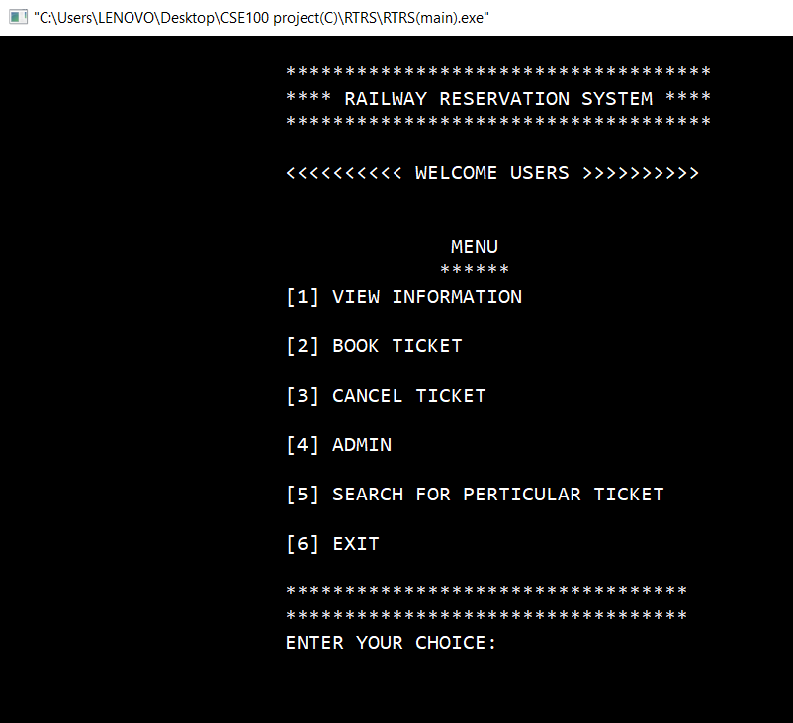

**Figure 5.6: User Menu**

**2) Book Ticket**

This option will want to know from the users that how many tickets they want to buy and other information’s. It is shown in figure 5.7.

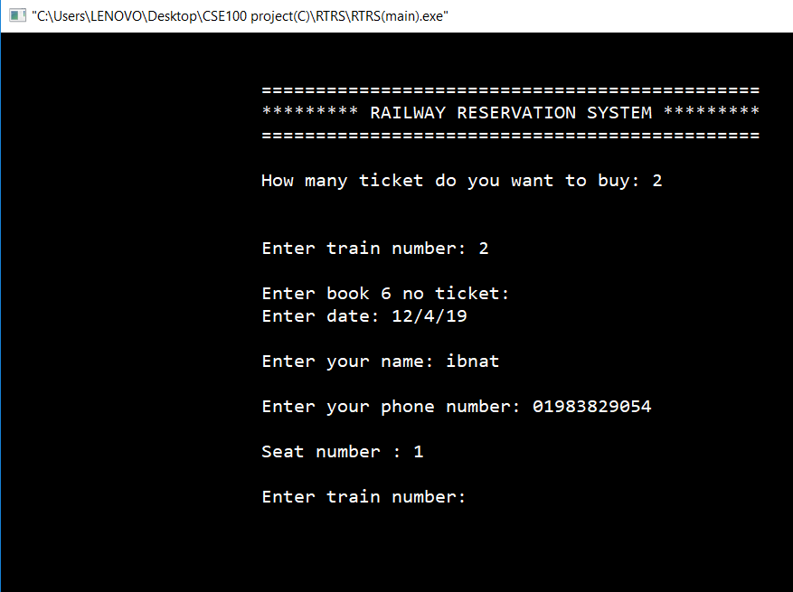

**Figure 5.7: Book ticket**

**3) Cancel Ticket**

This option will show the cancelation procedure of a user.It is shown in figure 5.8.

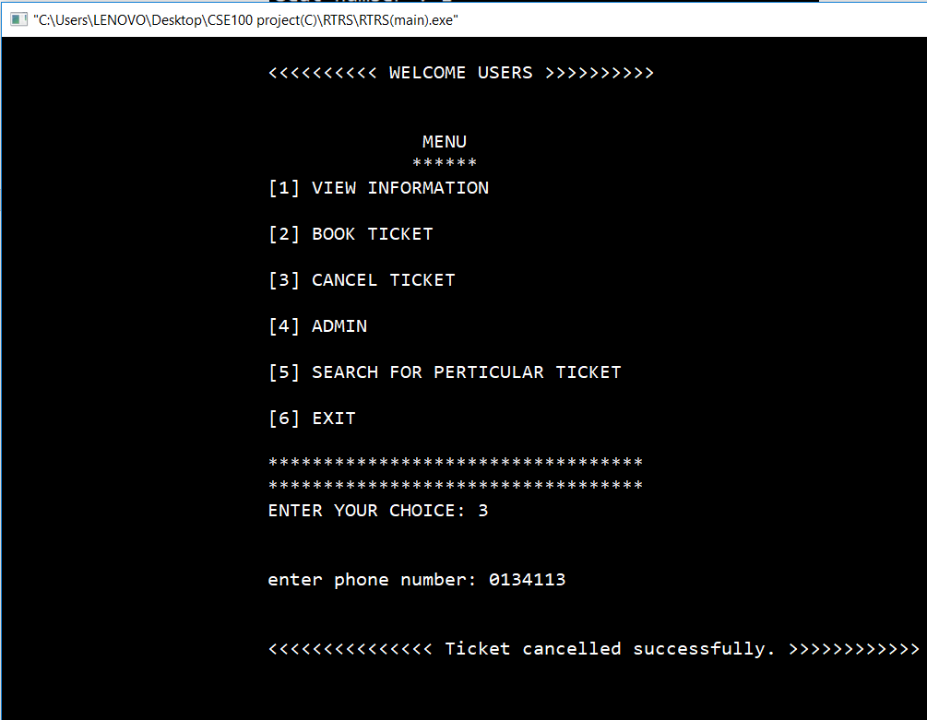

**Figure 5.8: Cancel Ticket**

**4) Search for Particular Ticket**

This option will allow the user to search for a particular ticket. It is shown in figure 5.9.

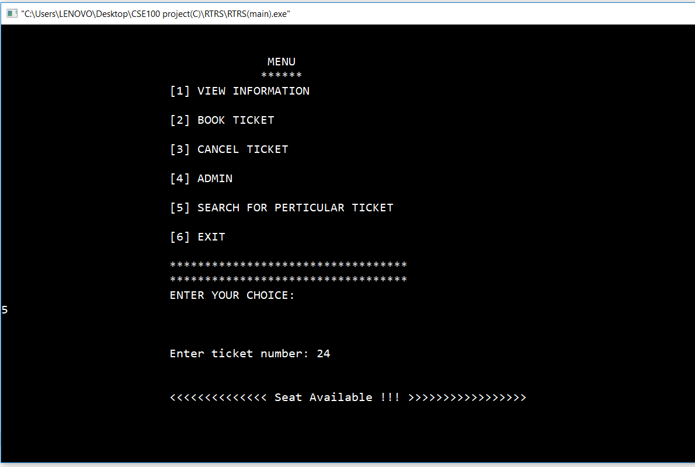

**Figure 5.9: Search for Particular Ticket**

**5) Exit from The System**

User can exit from the system. It is shown in figure 5.10.

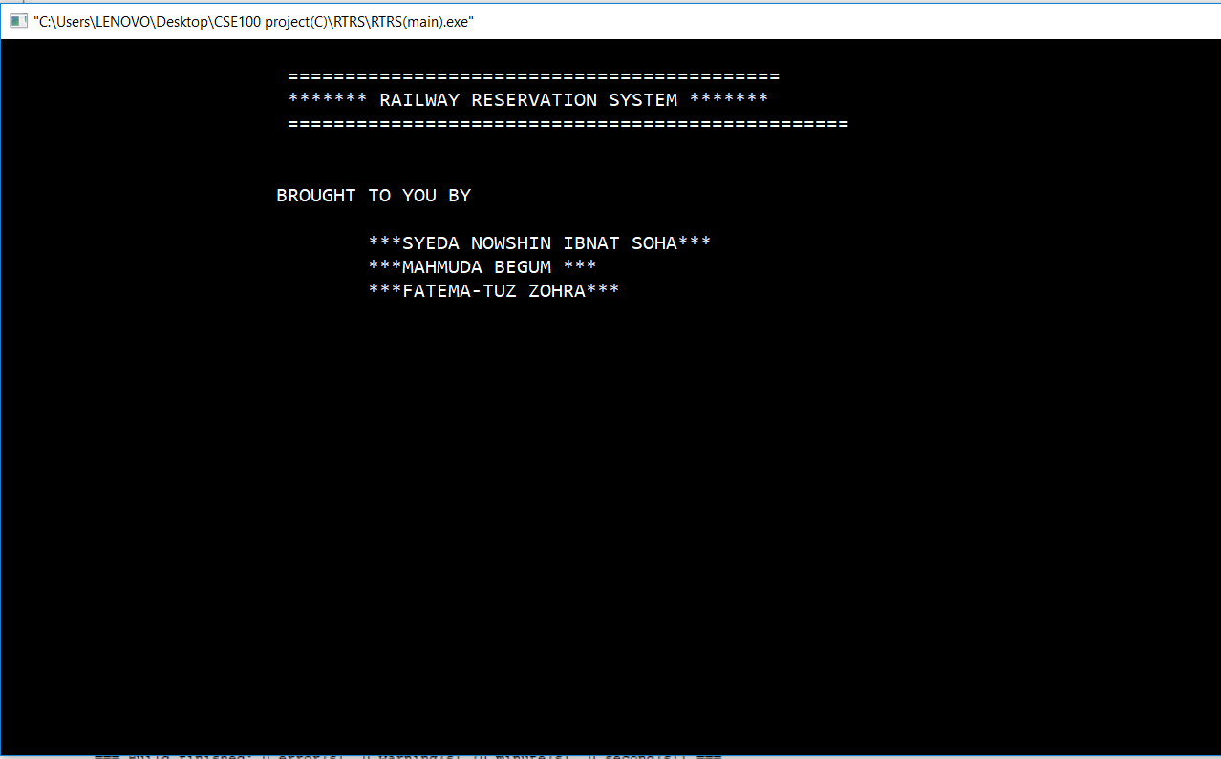

**Figure 5.10: Exit from The System**

**5.5 Conclusions**

Well-designed user interfaces can free the user from learning complex command languages. On the other hand, many users will find this easier and effective. They will find it with a command-driven interface, especially if they already know the command language. But it also helps those users who have not more knowledge about the program or system easily. It shows the direction to the user and admin to what to do. User can know the system facilities from here. Actually different management have different knowledge to implement their system procedure. We have tried to make our system as we want and the user want. Only a user friendly system can be successful otherwise it will go to vain. We have tried to make our project more eye catchy and more user friendly. If anybody see our project, he will find our services and the features except admin panel features at first. Hopefully it will be helpful for any reserving system.

**CHAPTER-6**

**CONCLUSIONS AND FUTURE PLAN**

**________________________________________________**

**6.1 Conclusions**

It was a great opportunity for us to work in “Railway Reservation System” as a fresh Programmer and design a system of it but there were surely some limitations while implementing this system. To reduce those limitations, we have some future plans also. This project is designed to meet requirements of a railway reservation system. By using this application, the company can provide reservation service and information to their passengers without limitations of office hours and manpower. It is also for the admins of the whole system who can look at the system like view passengers, add train, delete train. It is designed for use by the company internally manage their business processes; minimizing human errors and overcoming difficulties and problems that arose in the manual system.

The previous booking system was manual. It was not effective and time saving for the both passengers and admins. Passengers had to go to the station and had to queue in hours. But sometimes they had to go at home with empty hands because of unavailable tickets. On the other hand, for admins, they also had to keep paper records. For a system like railway reservation system here it is too difficult to maintain all the requirements on papers. As a fresher programmer it is more difficult to establish a dynamic project like this. Railway reservation Project is not about just booking Tickets. The others facilities of this project was more than reserving tickets. The facilities we have provided in this project was just fabulous to see. It was not an easy task for us. As an inexperienced programmer, to create dynamic project like this was too tough. We have tried all the basic knowledge what we know. We have produced all our previous two semesters experience on it. Everything was not always gone at our side. We had to face some critical problems. Thanks to almighty, we were able to recover that situations. We three were really well connected every single time to give our hundred percent on it. Hopefully this will be able to ensure that all the requirements are available as a dynamic Railway Reservation System.

**6.2 Future Plan**

Though we have tried our level best to make our system more user friendly and flawless by using structured programming language(C), some minor limitations exist in our system due to time constraints. The limitations of the system are-

1) We can’t input the home address and email address of passenger and there are no passwords for passengers to login to the system.

2) Payment system isn’t available in our system and we can’t show that passengers are purchasing tickets.

3)The software does not provide concession in fare rates for children, aged people i.e., the fare identical for all people.

4) Passengers can’t choose class or compartment of the train.

5)There is no information about admin. So passengers can’t contact if they need any help from admin.

The project made here just to ensure that is project could be valid in today’s real challenging world. Here all the facilities are made and tested to ensure easy and secure reserving system. In future the overall system will be extended when we will improve our project. Then the users will get more services from our system.

In future these features will be added in our system-

1) Passengers can choose class or compartment of the train system.

2) Passengers can input email id and home address of them.

3) Add information about admin so that passengers can get help easily.

**References**

**Books:**

[1]. “TCP/IP Sockets in C” by Michael J. Donahoo, Kenneth L.

[2]. “The pocket guide to TCP/IP Sockets” by Kenneth L. Calvert.

[3]. “Programming with C” by Byron Gottfried.

[4]. Kernighan and Ritchie "The C Programming Language", 2nd ed, 1988, (The "K&R". The Bible for the C language).

[5].Plauger, "The Standard C Library", 1992.

[6]. **“**Expert C Programming: Deep C Secrets” by Peter van der Linden.

[7]. “The standard C library”by P.J.Plauger.

# [8]. “C Projects” by Reeta Sahoo

# [9]. “C Projects Paperback – Illustrated, 1 Jan 1995”

by [Yashavant P. Kanetkar](https://www.amazon.in/s/ref=dp_byline_sr_book_1?ie=UTF8&field-author=Yashavant+P.+Kanetkar&search-alias=stripbooks)

[10]. “[C in Depth” by Deepali Srivastava](https://www.amazon.in/C-Depth-Deepali-Srivastava/dp/8183330487/ref=pd_sbs_14_4/261-8966835-0727447?_encoding=UTF8&pd_rd_i=8183330487&pd_rd_r=bb231760-9060-11e9-840c-c968a26de05d&pd_rd_w=tIhMN&pd_rd_wg=QAhER&pf_rd_p=87667aae-831c-4952-ab47-0ae2a4d747da&pf_rd_r=RVCG2W8Y6Q74D2FK5Q11&psc=1&refRID=RVCG2W8Y6Q74D2FK5Q11)

# **Websites:**

# [1]. <http://www.railway.gov.bd/>

[2]. <https://www.wikipedia.org/>

[3]. <https://www.scribd.com/>

[4]. <https://www.ques10.com/>

[5]. <https://www.slideshare.net/>

[6]. <https://www.academia.edu/>

**APENDIX A**

**Code Blocks control settings**

1] Use tab character

2] Syntax highlighting

3] Source code formatter

4] Code abbreviations

5] Enable all warnings

6] AutoComplete

7] Creating new build target

# **How to Install Code Blocks in Windows**

Code blocks installation in Windows is very easy. Code::Blocks is free, cross-platform IDE(integrated development environment).

**Step 1:** Go to www.codeblocks.org

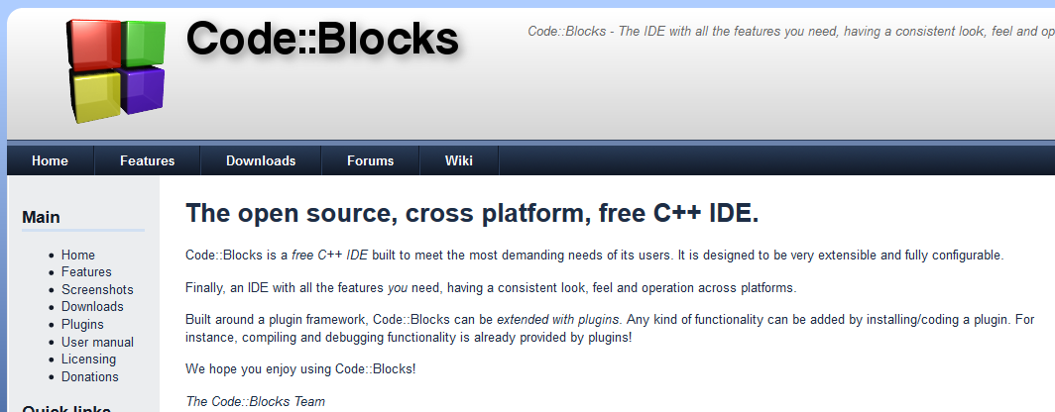

**Step 2:** Go to Downloads

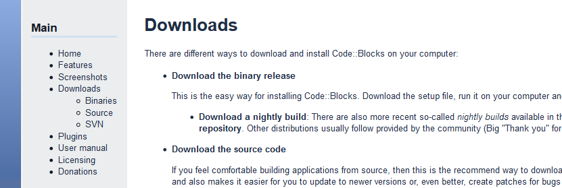

**Step 3:** Look at the left sidebar. Click on Binaries

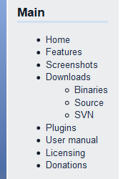

**Step 4:** Click on Windows 2000/XP/Vista/7/8

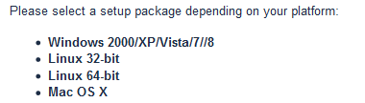

**Step 5:** We want to install codeblocks-12.11mingw-setup.exe. Click on the  
Sourceforge.net link to the right of it. This is the version with the GCC compiler.

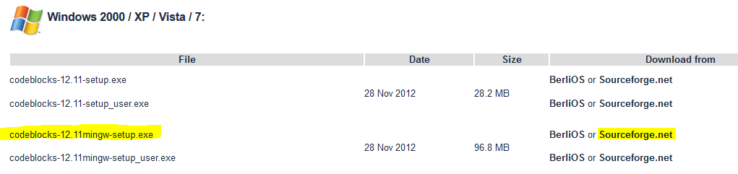

*If the download file does not pop up after a few seconds, use the direct link provided at the top of the page by the Code::Blocks logo.

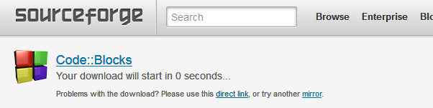

**Step 6:** Go to your downloads folder and double click on codeblocks-12.11mingwsetup.exe. A warning will pop up, click yes.

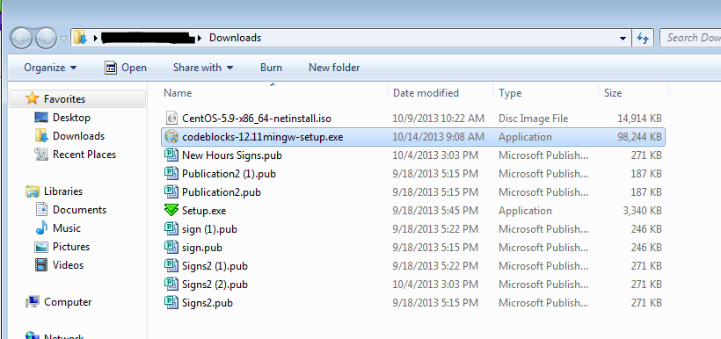

**Step 7:** The set up wizard will appear. Click next.

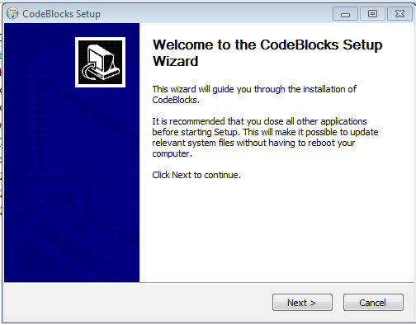

**Step 8:** Click I agree.

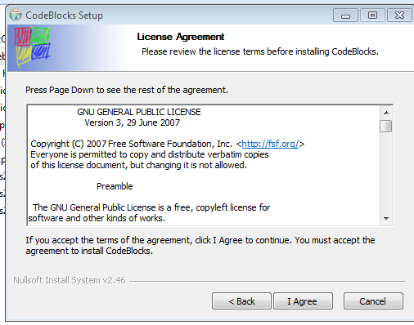

**Step 9:** Click next.

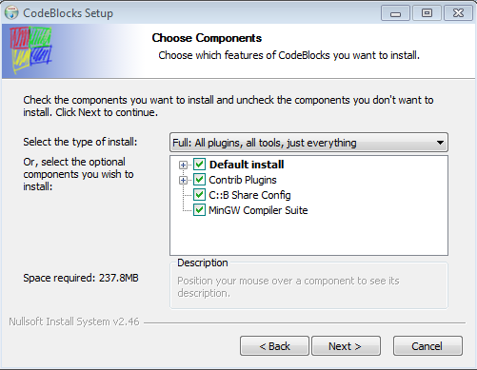

**Step 10:** Click Install. Code::Blocks will immediately start installing and should  
take less than 5 minutes.

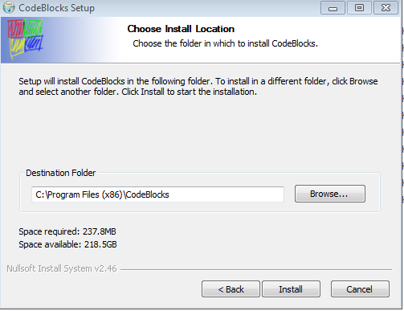

**Step 11:** If you want, start Code::Blocks now. If not, click no, then next.

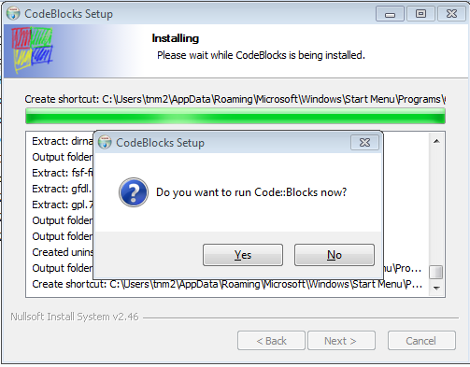

**Step 12:** Click finish.

